Week 4 Rules-Merge Meeting — Agenda & Working Notes
Nov 6, 2026 · prepared by @Kristina

Opening
This doc compares three independently-written rules.md files — Kristina's, Anthony's, and Abigail's — for ingesting books.csv/books-batch2.csv. The goal of this call is to land on ONE shared rules.md the group will build tests and an ingest script against.
63 distinct decisions were identified across the three files: 40 are addressed by two or more of you (22 by all three — 7 full agreement, 9 where two agree and one differs, 6 where all three differ; 18 by exactly two), and 23 are addressed by only one person (2 Kristina, 4 Anthony, 17 Abigail).
Full backing detail — every decision, both example-table walkthroughs — is in rules-comparison.md in the repo. This doc is the agenda for the ones that actually need a decision, with live space below to record what the group agrees on.
How to use this doc: each decision item has a one-line summary of where the three of you stand, plus blank Decision and Notes areas — type directly into them during the call.

Agenda
- Decision 1: What identifies a book?
- Decision 2: Reject vs. warn-and-keep for an isolated bad ISBN
- Decision 3: No usable ISBN at all
- Decision 4: Update semantics — what counts as "this book changed"?
- Decision 5: Database schema
- Decision 6: Is title comparison case-sensitive?
- Decision 7: Report format and run-status tiers
- Open items: adopt-worthy additions, and what's in/out of scope
- Action items and next steps

Decision 1: What identifies a book?
Kristina and Anthony both use a valid ISBN as the book's identity (converting ISBN-10 to ISBN-13 when needed). Abigail uses goodreads_book_id as the primary identity, with ISBN as a secondary, validated attribute.
This is the single most consequential disagreement — it's upstream of whether a no-ISBN book can be loaded at all, what counts as a duplicate, what the schema's primary key is, and whether title changes get updated or rejected. See rules-comparison.md §2.1 and worked examples #23/#24 for a concrete before/after.
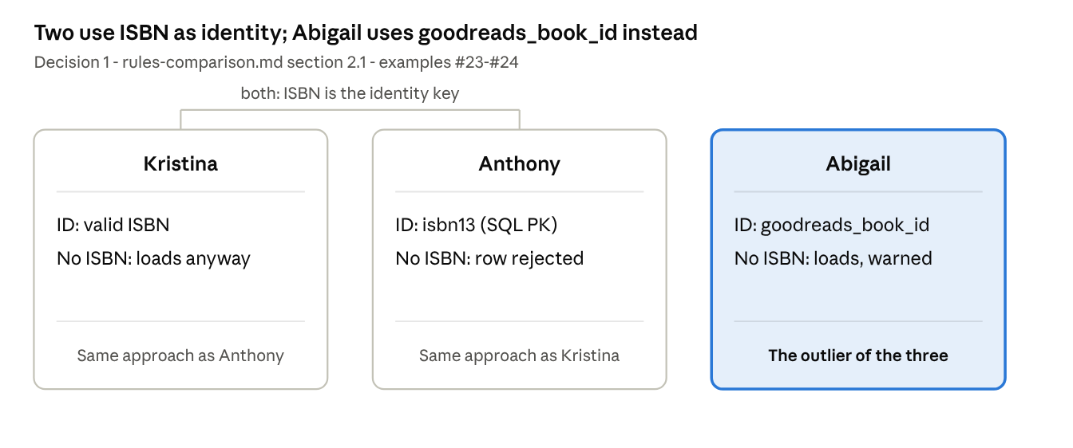
identity model · 3 approaches compared
Decision: Use Abby’s and only use “ good read book list”
Notes:

Decision 2: Reject vs. warn-and-keep for an isolated bad ISBN
Kristina and Abigail agree: a bad-but-isolated ISBN problem (wrong check digit, invalid characters, unrecoverable scientific notation, etc.) should null that one field, load the row, and attach a warning — never discard the whole book over it. Anthony's rules reject the row outright for several of these same situations (BAD_CHECKSUM, CORRUPT_CHARACTERS, INVALID_LENGTH, UNRECOVERABLE_ISBN13, NON_BOOK_IDENTIFIER).
This single question drives most of the differences in both example-table walkthroughs. See §1, rows 1.5, 1.7, 1.8, 1.9, 1.11, 1.14.
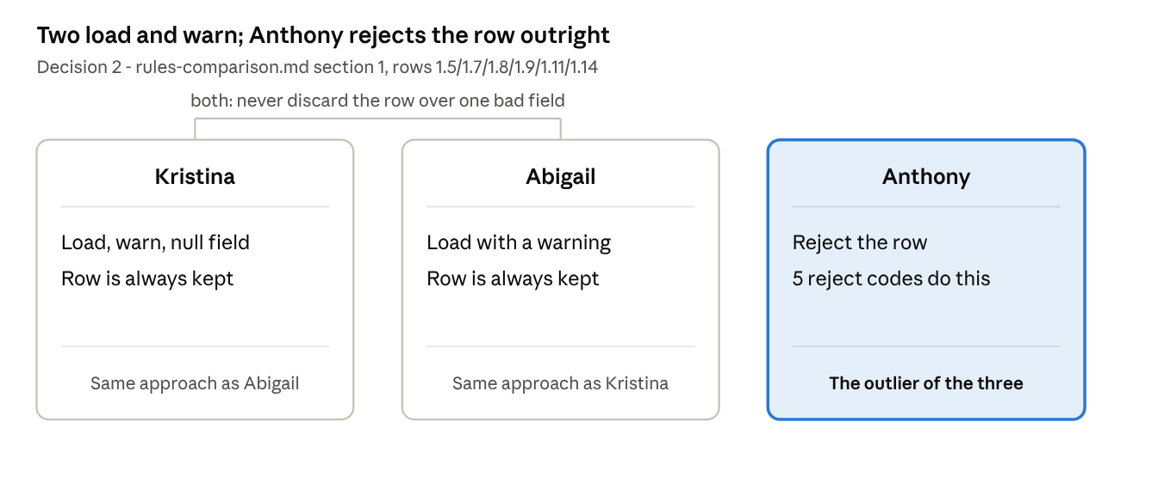
reject vs warn-and-keep · 3 approaches compared
Decision: Go with Kristina’s rule ( Load, warn, null field, row is always)
Notes:

Decision 3: No usable ISBN at all
All three differ. Kristina loads it silently (not even a warning). Abigail loads it with a warning. Anthony rejects the row outright. Given how common this is likely to be in the real dataset, this alone could make the three resulting databases wildly different sizes. See §1 row 1.13 and worked examples #10/#21.
Decision: Abigail loads it with a warning, due to other available resources to look up ISBN numbers like “Open Library”
Notes:

Decision 4: What counts as "this book changed," and can ISBN ever change?
Three different answers. Kristina updates any substantive field that changes, including title corrections and rating counts. Anthony only fills a previously-NULL field, on a 3-column whitelist (isbn10, publication_year, secondary_isbn10) — title isn't updatable at all. Abigail splits fields into two camps: volatile metadata (ratings, counts, image URLs) updates freely; identity-relevant fields (title beyond whitespace, author, year, work_id, language, and any ISBN change) reject the row and leave the existing record untouched.
Worked example #24 (same ISBN, title corrected) shows Kristina updating exactly the case Anthony and Abigail both reject. See §3, rows 3.3, 3.4.
Decision: use: Abigail splits fields into two camps: volatile metadata (ratings, counts, image URLs) updates freely; identity-relevant fields (title beyond whitespace, author, year, work_id, language, and any ISBN change) reject the row and leave the existing record untouched.
Notes:

Decision 5: Database schema
All three differ. Kristina: books + separate warnings tables. Anthony: one books table, no ratings/metadata columns at all, no goodreads_book_id. Abigail: implies the full goodbooks-10k column set (ratings, counts, language, goodreads_book_id, work_id, etc.).
This needs deciding before anyone writes a CREATE TABLE statement — and is downstream of Decision 1 (the identity model) and whether the group wants to track Goodreads metadata at all. See §5.
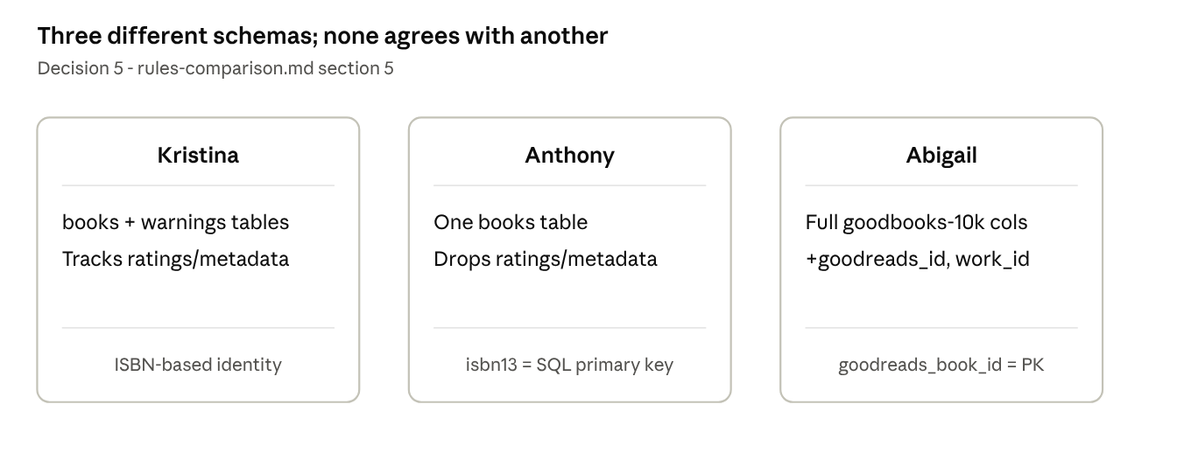
schema comparison · 3 approaches compared
Decision: Kristina to add Good read ID, then share ERD and Abby and Anthony to update their database structure
Notes:

Decision 6: Is title comparison case-sensitive?
Kristina and Anthony both lowercase titles before comparing. Abigail treats a capitalization-only change as a reportable conflict (case-sensitive).
Smaller than the others, but it changes how many rows get flagged for review. See §2 row 2.4.
Decision: Remove cap. sensitivity
Notes:

Decision 7: Report format and run-status tiers
Kristina and Abigail both require a single unambiguous top-level verdict, headline counts by outcome, a per-category breakdown, and per-row actionable detail. Anthony's rules don't state report requirements at all (though his reason codes could feed one).
Abigail additionally defines a three-tier run status (SUCCESS / COMPLETED WITH ISSUES / FAILED, where FAILED means nothing is saved) — neither Kristina's nor Anthony's rules say what happens if a run fails catastrophically partway through. See §4.
Decision: Go with Abby’s reporting requirements
Notes:

Open items: adopt-worthy additions, and things to scope in or out
These aren't disagreements — they're real material only one person's rules cover, worth a quick yes/no from the group:
- Anthony's extra repair rules (deriving ISBN-10 from a valid ISBN-13, the "stripped-978" repair) and his multi-code reporting (listing all applicable reason codes on one row).
  - Implement
- Abigail's handling of publication year, missing title/author, and language code — real problem categories neither Kristina's nor Anthony's rules considered.
  - Skip this, do not implement
- Abigail's atomicity guarantee: a failed run saves nothing, ever.
  - Skip this, do not implement
- Abigail's external lookup + human-approval correction workflow (lookup_isbns.py, Open Library lookups, an isbn-corrections.csv approval file, a "note" status for approved no-ISBN books). This is a substantial process addition, not a tweak — decide whether it's in scope for this assignment at all, separate from the rules-merging discussion.
  - Skip this, do not implement
- A shared gap: neither Kristina's nor Anthony's rules check the ISBN-13 prefix (978/979) explicitly — only Abigail's does. Worth confirming this isn't an oversight either of you wants fixed.
  - Implement
Decision:
Notes:

Action items and next steps
(fill in live — who owns writing the final shared rules.md, by when, and who builds which test suite)
- ☐
- ☐
- ☐

